**Complaints and Compliments**

**Guidance & Form**



We want to know what’s good about our service. This is a compliment. We like to hear everyone’s compliments so we can tell staff when they are doing something well.



We all learn from compliments and complaints and they can help us make the services we provide better.





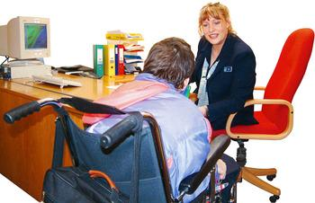



**How do I make a complaint?**







You can also raise concerns or make a complaint with your social worker. The customer service centre for your local authority can be contacted on the following telephone numbers:

**Haringey: 020 8489 1400**

**What will happen if I make a complaint?**











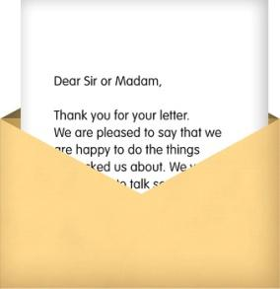



** **





If you are still not happy, you can complain to the Local Government Ombudsman at:

The Local Government Ombudsman

PO Box 4771

Coventry

CV4 0EH

Tel: 0300 061 0614

Email: advice@lgo.org.uk

[www.lgo.org.uk](http://www.lgo.org.uk)

Shine Bright Care is registered by the Care Quality Commission who can be contacted at:

Care Quality Commission National Correspondence

Citygate

Gallowgate

Newcastle upon Tyne

NE1 4PA

Tel: 0300 061 6161

[www.cqc.org.uk/contactus.cfm](http://www.cqc.org.uk/contactus.cfm)

**Our commitment to you**

* We will welcome all comments and complaints.
* We will treat what you tell us seriously.
* We will treat you fairly and with respect.
* We will respond to your complaint as soon as we can.
* We will keep you informed about how we are responding to your complaint.
* If you ask us not to tell someone you have complained or not to share something you tell us, we will seek to respect that request and will let you know if we do not think we can do that.
* We will explain any decisions we make.
* We will be open, honest and admit any mistakes or poor practice.
* We will look for things we can do better and make those changes.
* We will keep a record of every complaint and our response.

A copy of this complaints process will be given to each person we support and a copy will be on display in each community where support is provided.

**Complaints Form**



**My name is: ________________________**



**My address is:**

**________________________**

**________________________**

**________________________**



**My phone number is:**

**______________________**

**I would like to tell you about:**

|  |
| --- |

**This is what I would like to happen:**

|  |
| --- |

**Please return this form to your manager.**